Mexico Foreign Press Chatter
January 23, 2026
Coverage continued to focus on the mounting pressure the U.S. is putting on the Sheinbaum administration. The NYT reported on the transfer of 37 alleged cartel members to the U.S., the third such operation, aimed at reassuring Trump that bilateral cooperation is real. The WSJ detailed that the national security laws used to move cartel-linked prisoners bypassed a legal but lengthy extradition process. Taking a broader view, The Economist argued that Trump’s threats have spilled into Mexico’s economic vulnerability by binding security to U.S.-Mexico trade, leaving Sheinbaum to navigate the crisis with an increasingly authoritarian Morena shaped by AMLO’s influence.
Meanwhile, the AP reported on images circulating of a U.S. military plane in an airport outside Mexico City, which reignited speculation about potential American activity on Mexican soil; Sheinbaum quelled such concerns, saying it was all part of previously planned joint training. For its part, the LA Times illustrated the security crisis social cost by following deported Mexican migrants returning to cartel-ravaged towns only to confront a completely transformed Mexico, where cartel targeting forces them into “double-displacement”. Staying on bilateral tensions, the NYT provided further details on Cuba’s crisis – and Mexico’s oil shipments to the island.
On business and the economy, Bloomberg took a deep dive into the success of Chinese EV manufacturer BYD in Mexico, citing affordable models, favorable financing, and fuel savings, as key drivers, arguing that the company has essentially created a market for EVs in Mexico that U.S and Japanese competitors thought didn’t exist. The WSJ also reported on the global rise of BYD cars, noting that their popularity in Mexico has made them a “forbidden fruit” for American consumers. Tariffs of up to 50% now loom as part of an effort to reduce dependency on China, but Bloomberg suggests tariffs will be absorbed and demand is unlikely to soften. Elsewhere, Bloomberg reported that Carlos Slim will purchase Fieldwood Mexico from Russia’s Lukoil, gaining full ownership of the Ichakil and Pokoch oil fields, reinforcing himself as the largest private oil player in the country. On a bright note, Reuters reported that the Mexican economy grew 2.3% in December compared to last year, while Bloomberg noted inflation rose less than expected during the first two weeks of January, as policymakers weigh a possible pause in rate cuts
Shifting gears, and reflecting the foreign press ongoing obsession with Axolotls, The Guardian explored Axolotl’s global cultural popularity, as Mexico’s endemic salamander is now common in toys, fashion, and social media, gathering attention for its childlike, almost alien appearance and their remarkable regenerative abilities, even though they face near extinction and a grim reality in the wild. AxoIn sports, the AP profiled Mexico’s Women’s flag football quarterback, Diana Flores, as a global ambassador for the sport and reported on Richard Ledezma, a Mexican-American soccer player, switching allegiance from the U.S. to Mexico, part of a widening pull on American-born players with Mexican heritage.
Lastly, and most importantly, the NYT offered an updated 36-hour schedule for those fortunate to be visiting Mexico City. Most recommended.

Notable blogs in English on Mexico
The Mexico Political Economist reported on Mexico’s auto industry position a year after U.S. tariffs went into effect, noting a stagnation in exports and a changing industry that was built on auto parts crossing the border multiple times. Mexico Decoded detailed the structure of the liquid petroleum gas industry, a concentrated cartel-like oligopoly that institutionalizes concentration, bypasses regulation, and limits entry, which results in higher prices for a household good. The Mexpatriate explores survey data for Mexico’s alcohol, drug, and tobacco consumption, arguing that the data is limited and Mexico’s apparent non-issue regarding drugs and addiction may not reflect people’s actual experiences. In Crashout, Ioan Grillo explores the Sinaloa Cartel’s production of ‘Pink cocaine’ following a lab seizure early this month that found the drug in Mexico.

Photo of the Week
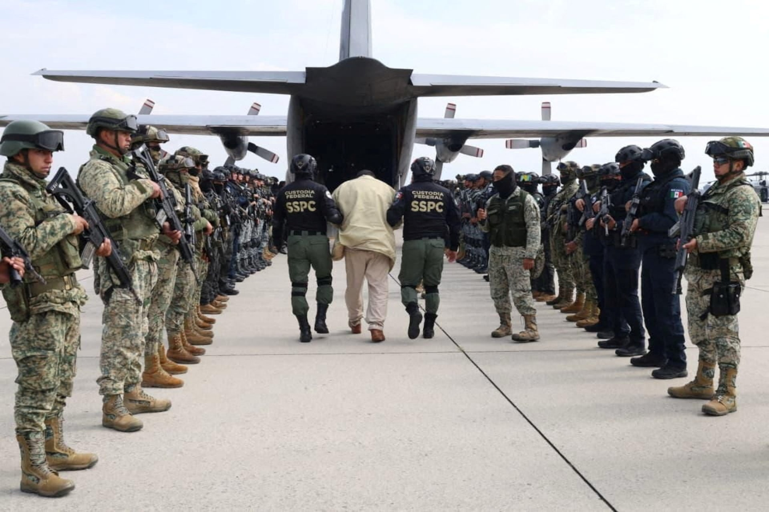
Security Ministry agents escort a detainee. The Mexican government sent 37 alleged cartel members to the United States. Handout photo by the Security Ministry, reproduced by Reuters.

FOREIGN PRESS COVERAGE
Pressured by Trump, Mexico Sends 37 Accused Criminals to U.S.
01/20/26, NYT, James Wagner

Mexico Delivers 37 People With Drug Cartel Ties to U.S.
01/20/25, WSJ, Santiago Pérez and Steve Fisher

Mexico’s mighty left-wing government is floundering
01/20/26, The Economist, Staff

Deported to danger: Returning migrants discover a Mexico transformed by cartels
01/18/26, LA Times, Steve Fisher and Kate Linthicum

Sheinbaum reassures Mexico after US military movements spark concern
01/19/26, AP, Staff

Mexican president highlights ‘compelling results’ in crackdown of cartels in face of Trump threats
01/16/26, AP, Staff

Can Cuba Survive Without Venezuela’s Oil?
01/17/26, NYT, Frances Robles

US Warns Airlines About Military Activity in Parts of Latin America
01/16/26, Bloomberg, Allyson Versprille

Chinese EVs Blow Past Tesla and Tariffs En Route to Global Reign
01/17/26, WSJ, Stephen Wilmot and Santiago Pérez

BYD’s Cheap EVs Are Suddenly Everywhere in Mexico as Tariffs Take Hold
01/21/26, Bloomberg, Amy Stillman

Mexican Billionaire Carlos Slim Snaps Up More Assets in Oil Push
01/19/26, Bloomberg, Amy Stillman

Mexico Inflation Rose Less Than Expected Before Rate Meeting
01/21/26, Bloomberg, Alex Vasquez and Gonzalo Soto

Mexico's economy up 2.3% y/y in December, preliminary estimate shows
01/21/26, Reuters, Staff

‘Every time I look at one, I smile!’: how axolotls took over the world
01/21/26, Guardian, Paula Cocozza

Richy Ledezma switches soccer allegiance from US to Mexico, joins national team
01/22/26, AP, Staff
QB Diana Flores hypes flag football ahead of its 2028 LA Olympics debut, now an open book on subject
01/20/26, AP, Pat Graham

36 Hours in Mexico City: Things to Do and See
01/22/26, NYT, Michael Snyder

